Week-02-Operators and Expressions, Managing Input and Output Operations

Week 02-01-practice session coding

Reg no : 241801291

Name : TARRUN.B

Q1)

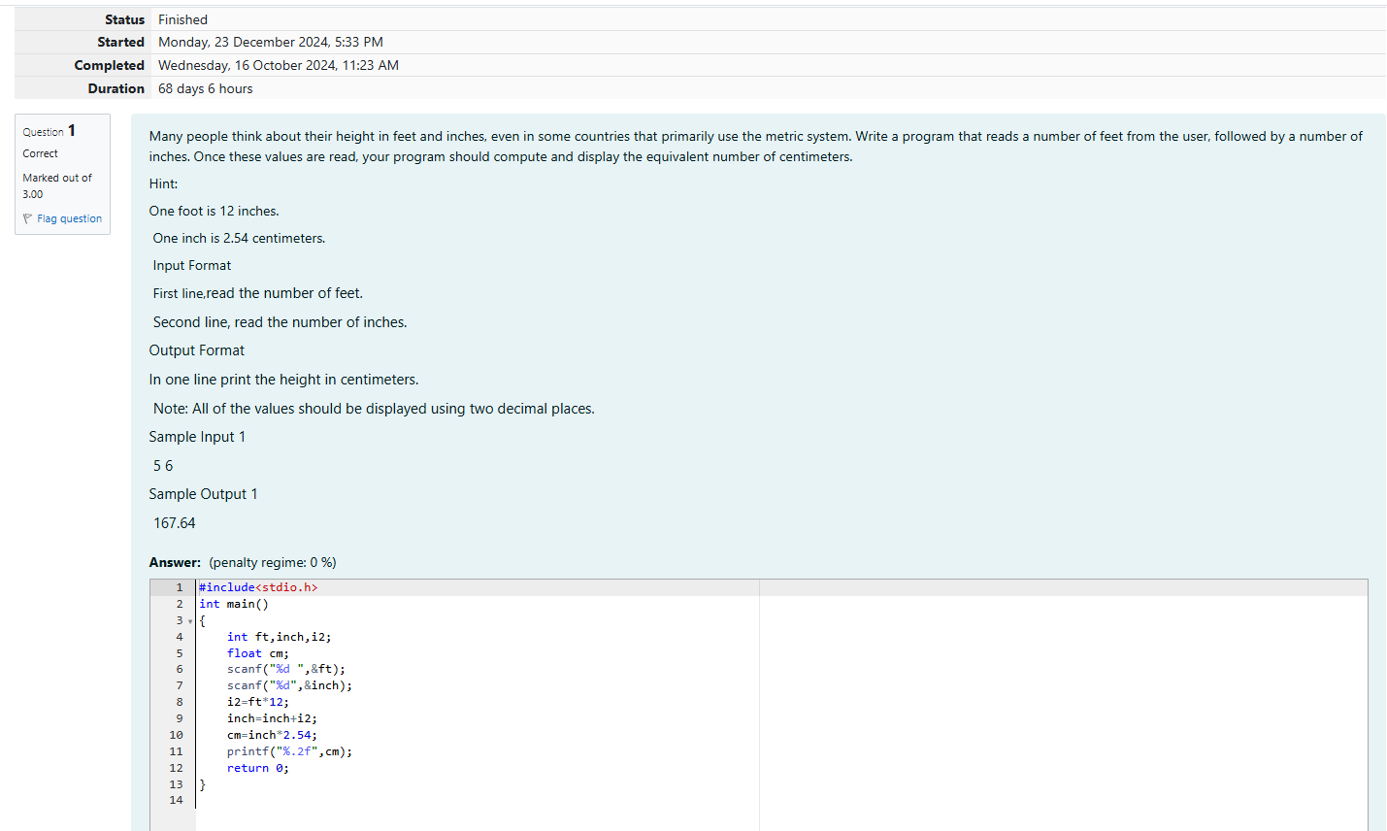

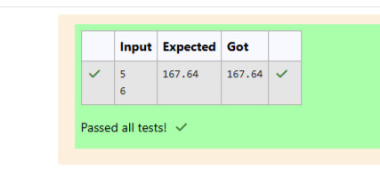

Week 02-01-practice session coding

Reg no : 241801291

Name : TARRUN.B

Q2)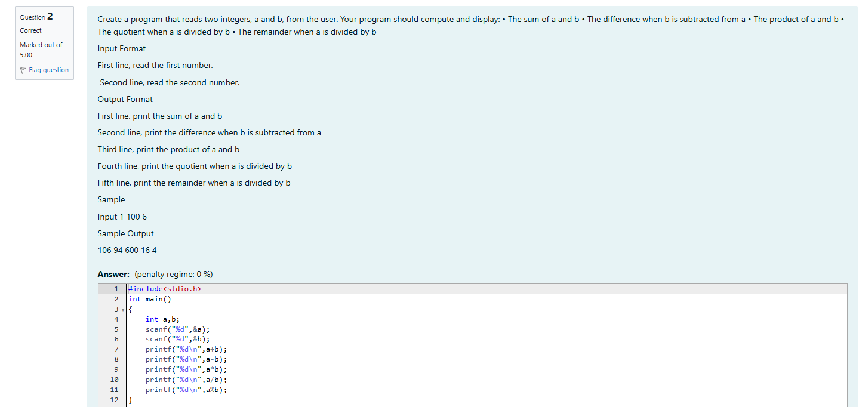

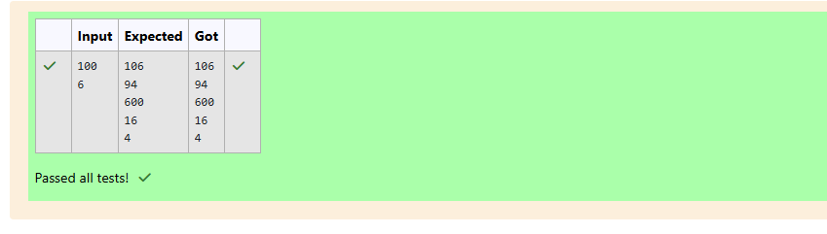

Week 02-01-practice session coding

Reg no : 241801291

Name : TARRUN.B

Q3)

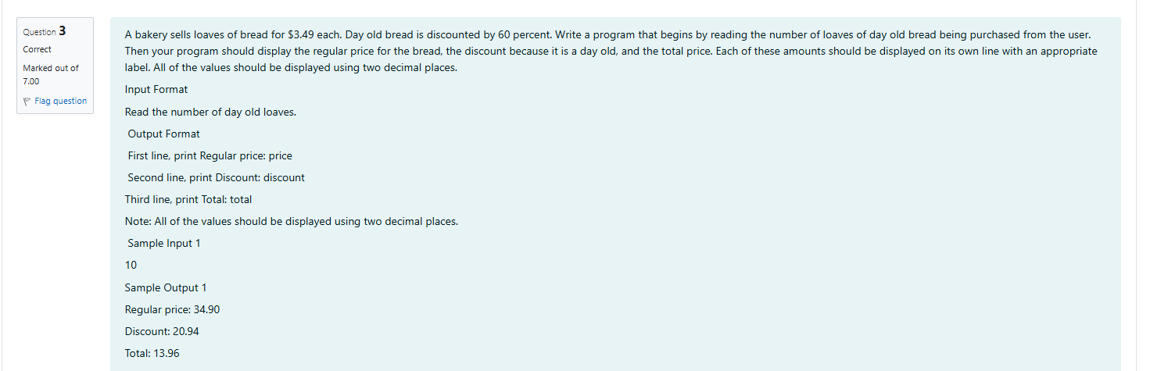

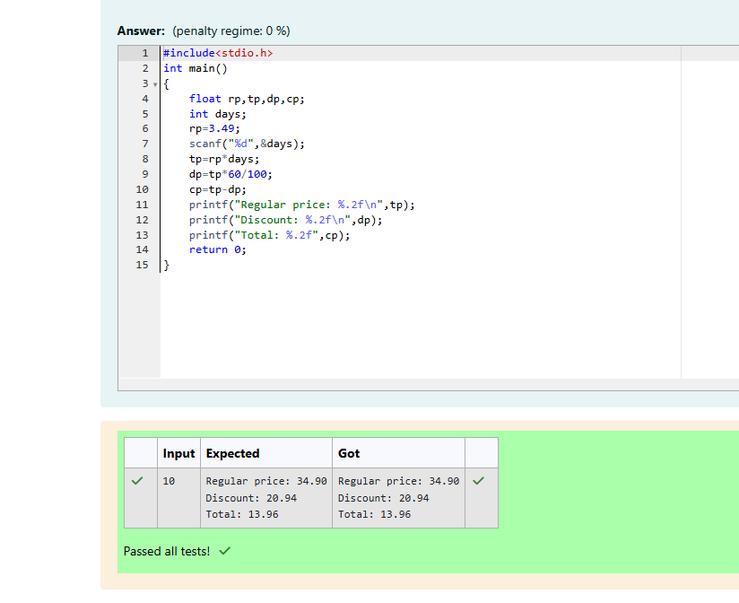

Week 02-02-practice session coding

Reg no : 241801291

Name : TARRUN.B

Q1) 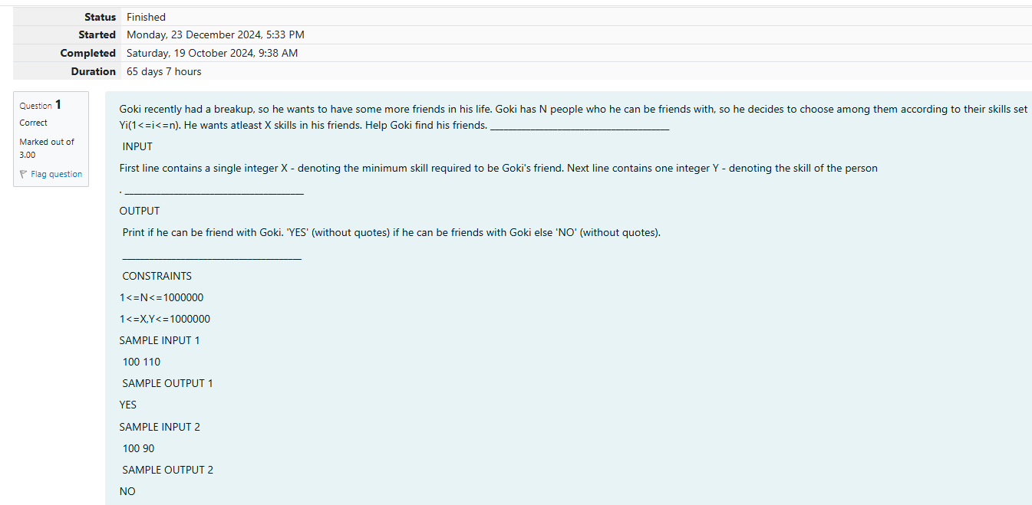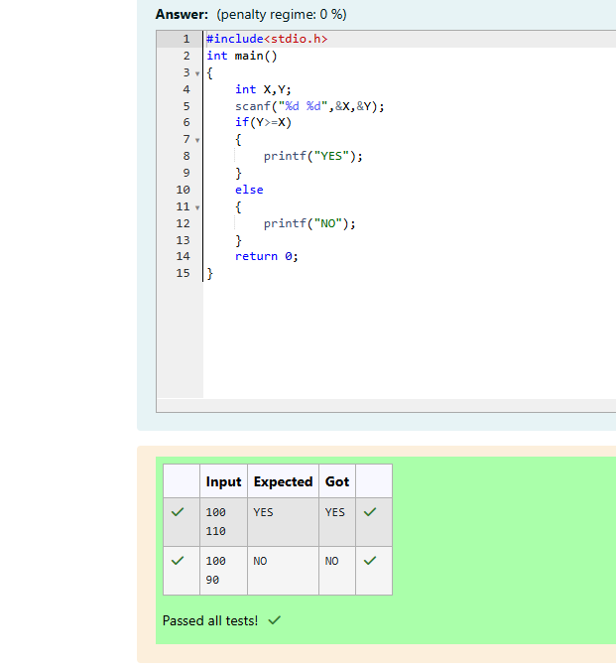

Week 02-02-practice session coding

Reg no : 241801291

Name : TARRUN.B

Q2) 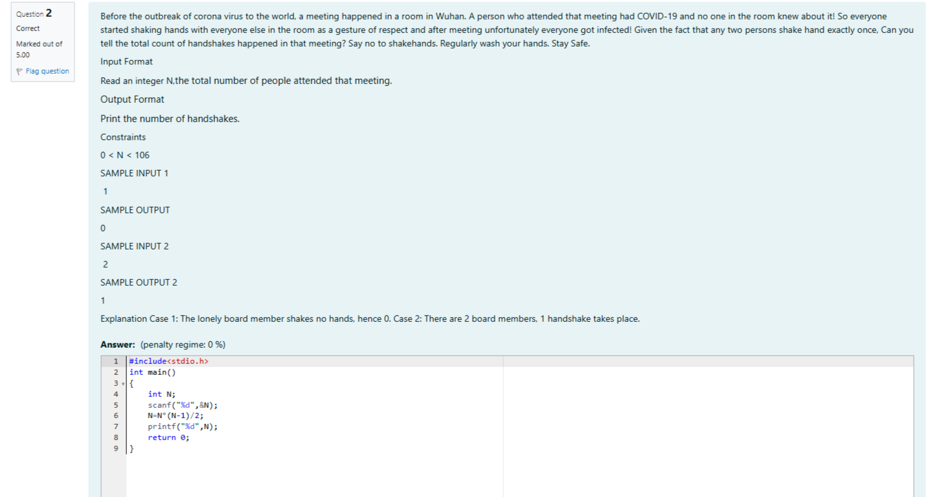

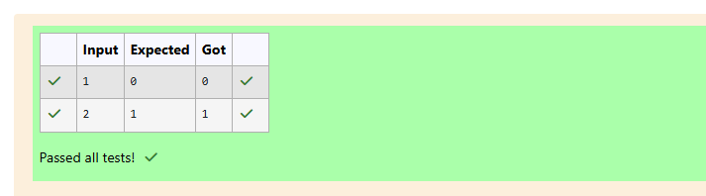

Week 02-02-practice session coding

Reg no : 241801291

Name : TARRUN.B

Q3)

